Nama : Ardacandra Subiantoro

NIM :18/427572/PA/18532

Tugas 2:

Bubble Sort :

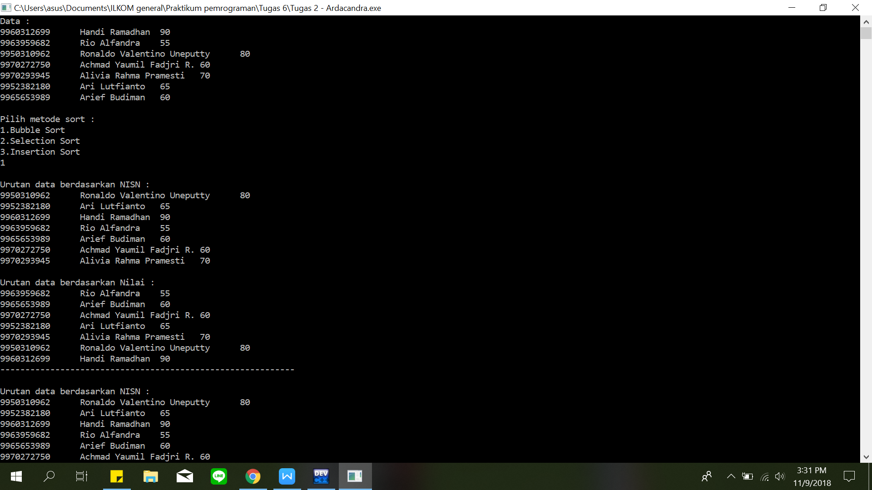

Selection Sort :

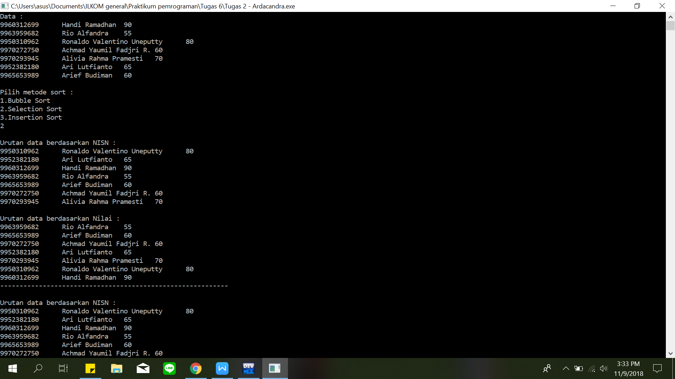

Insertion Sort :

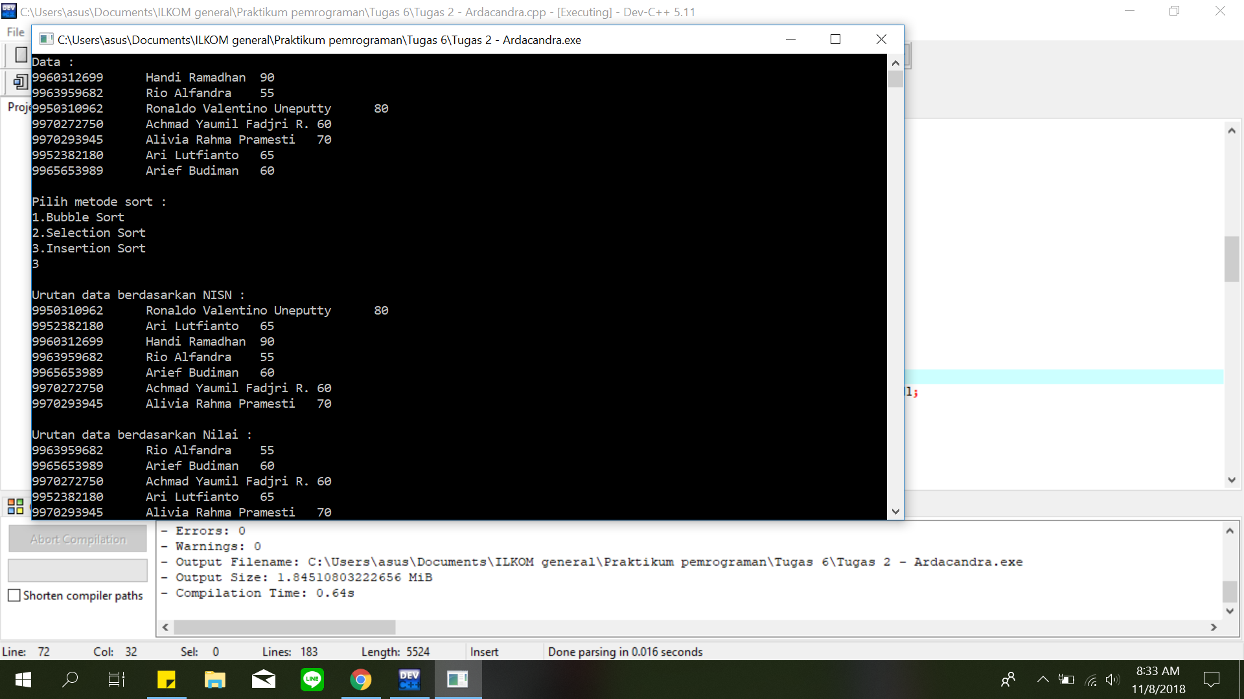

Nomor 2 dan 3 :

